Setup of Sqoop:

1. Go to the home page and select the add service tab:

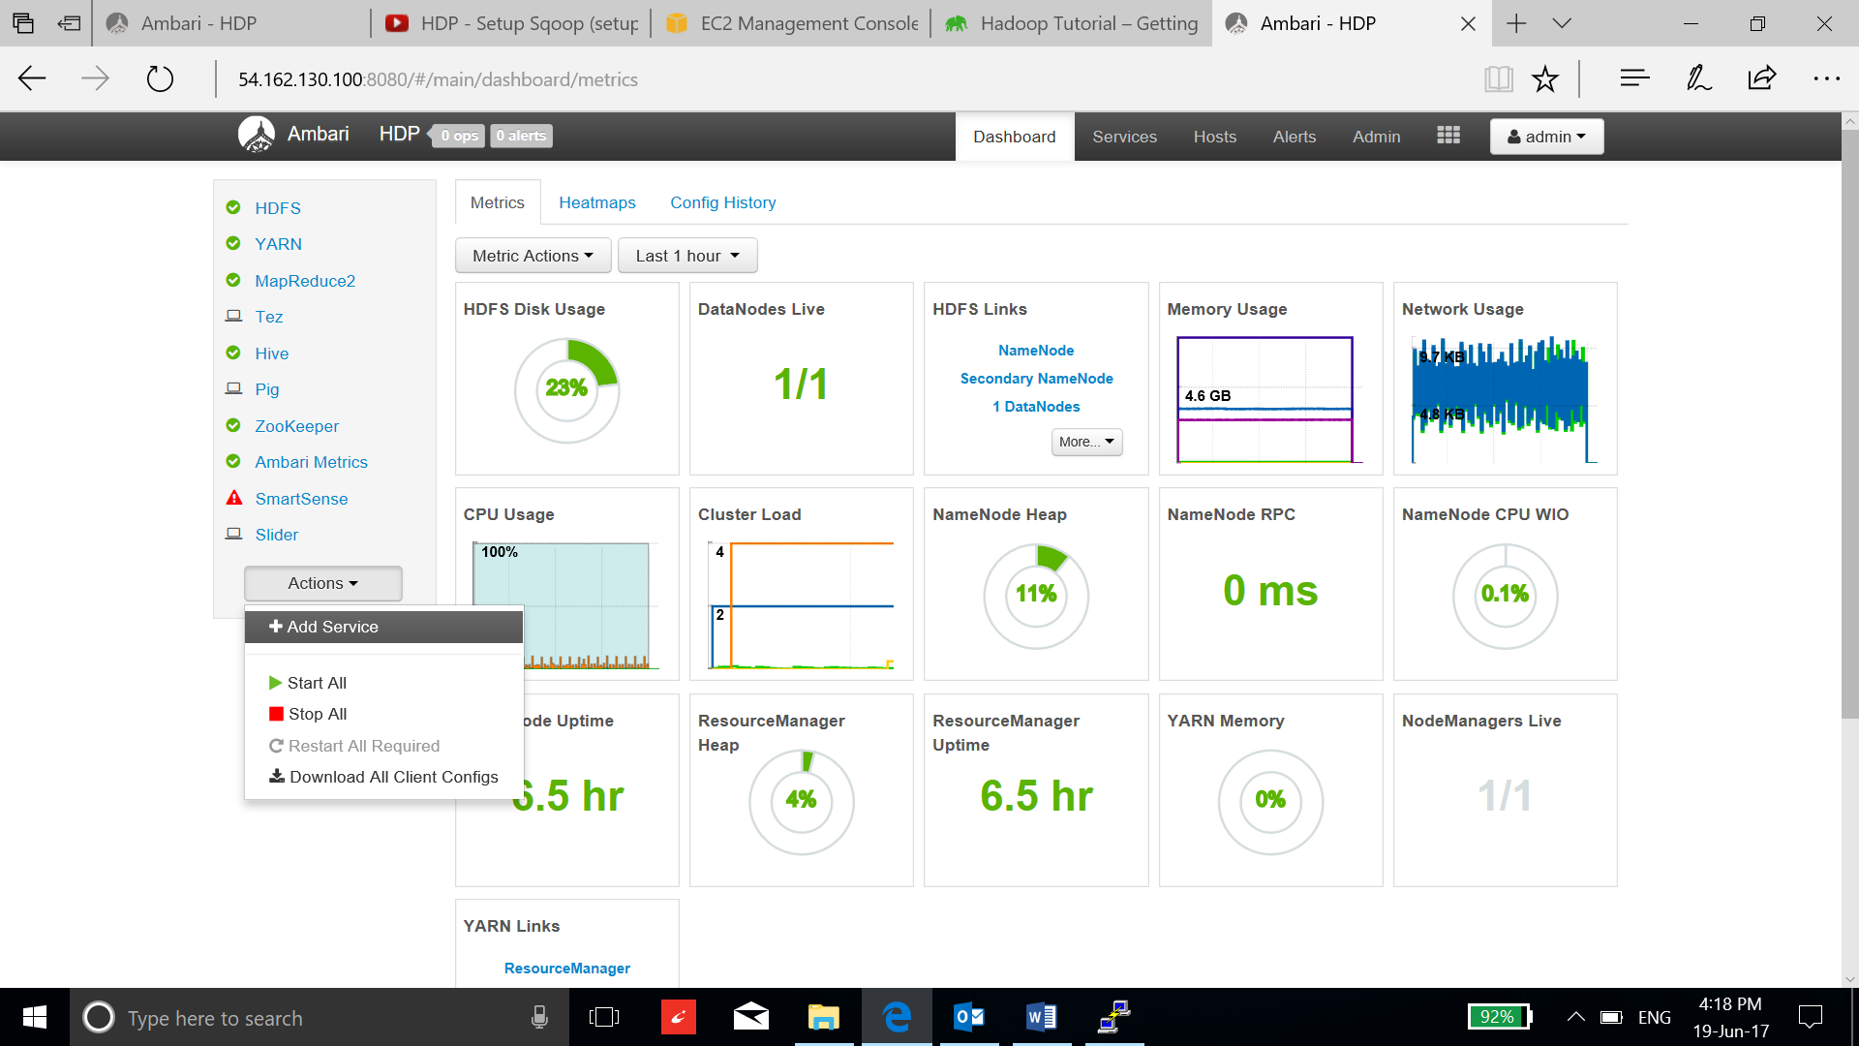

1. Tick the Sqoop service and select next:

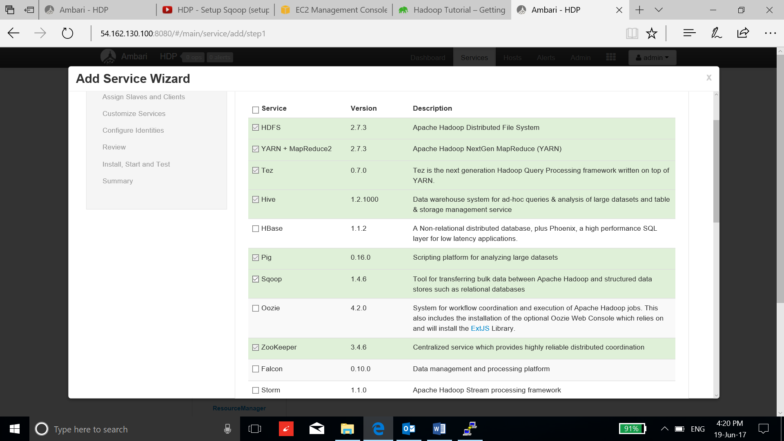

1. Select the clients to use Sqoop:

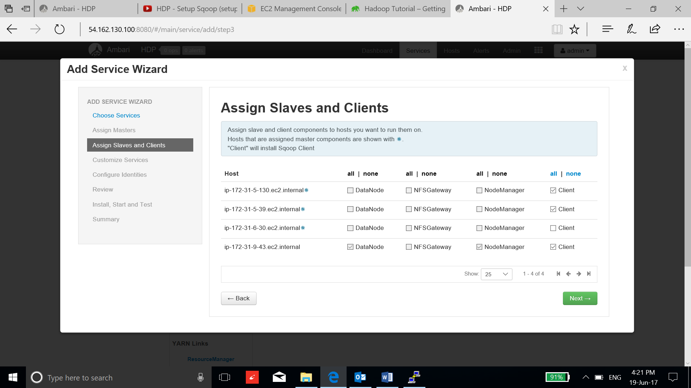

1. Leave the default configuration and select next.

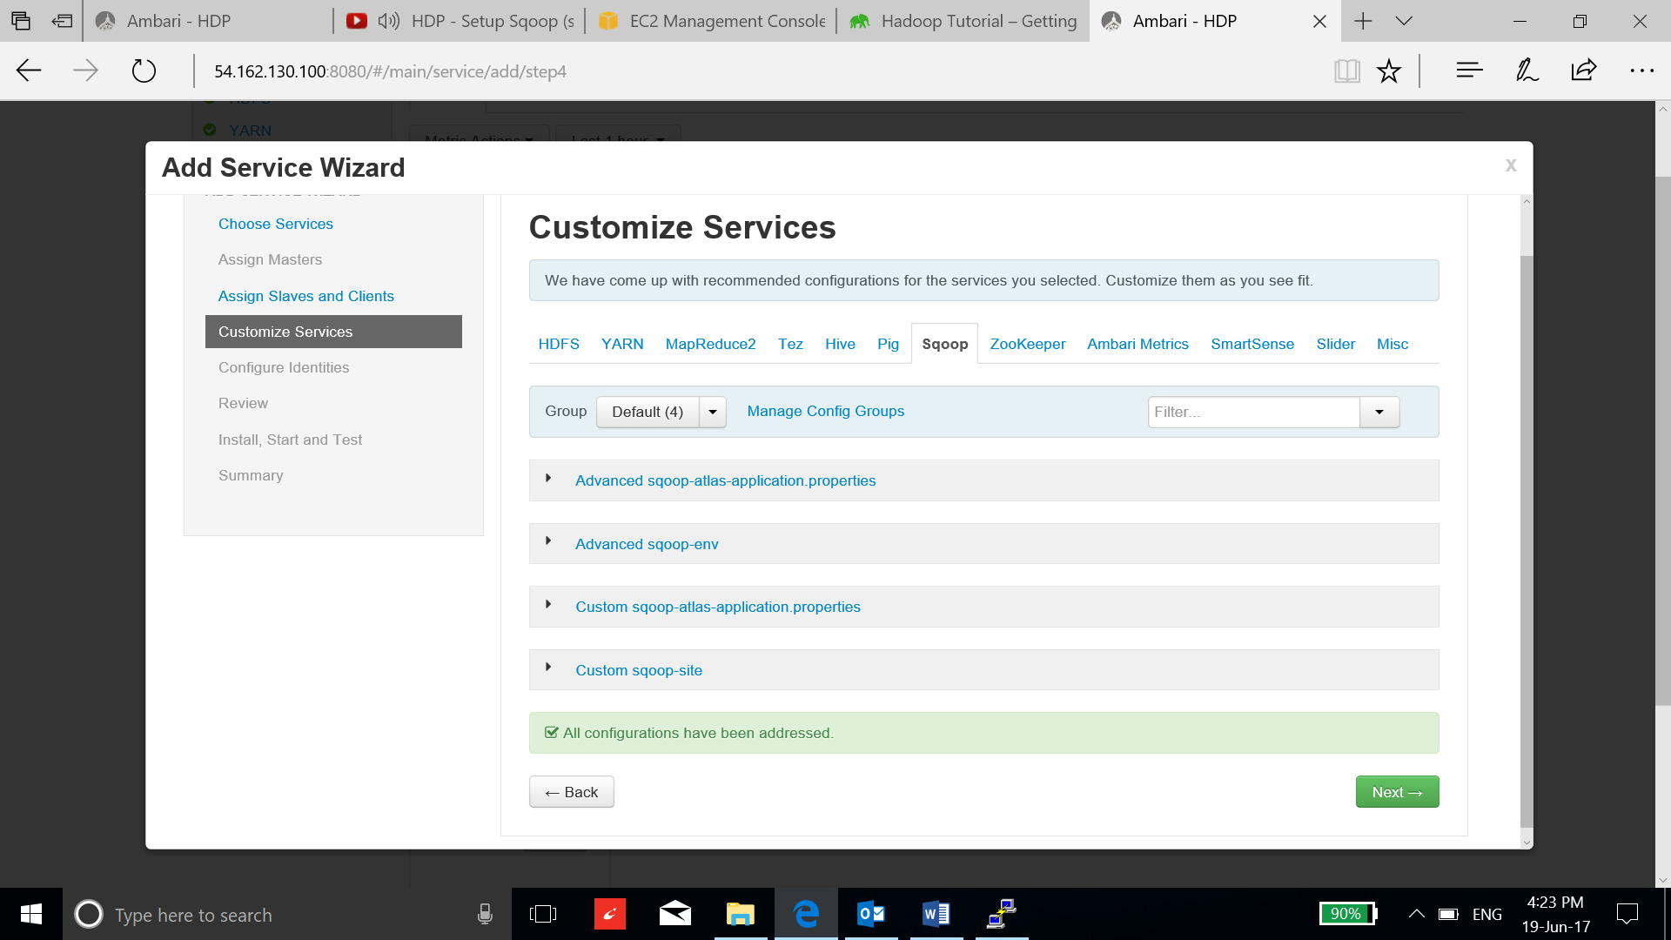

1. Review and Select the deploy button:

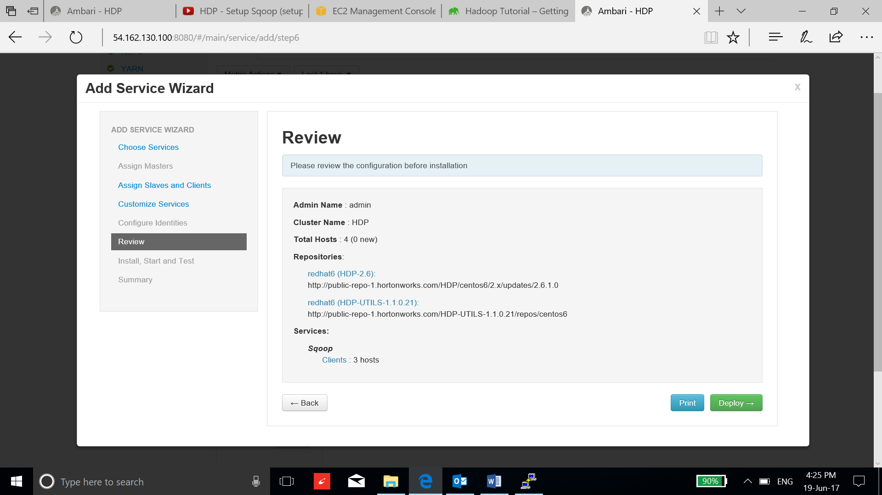

1. After successful installation, select next and complete the process.

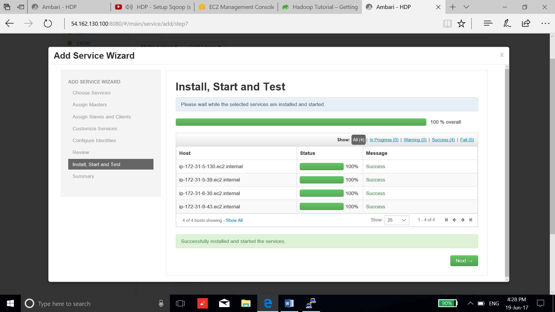

1. Now ssh to the instance and validate the installation with the following command:

**sqoop help**

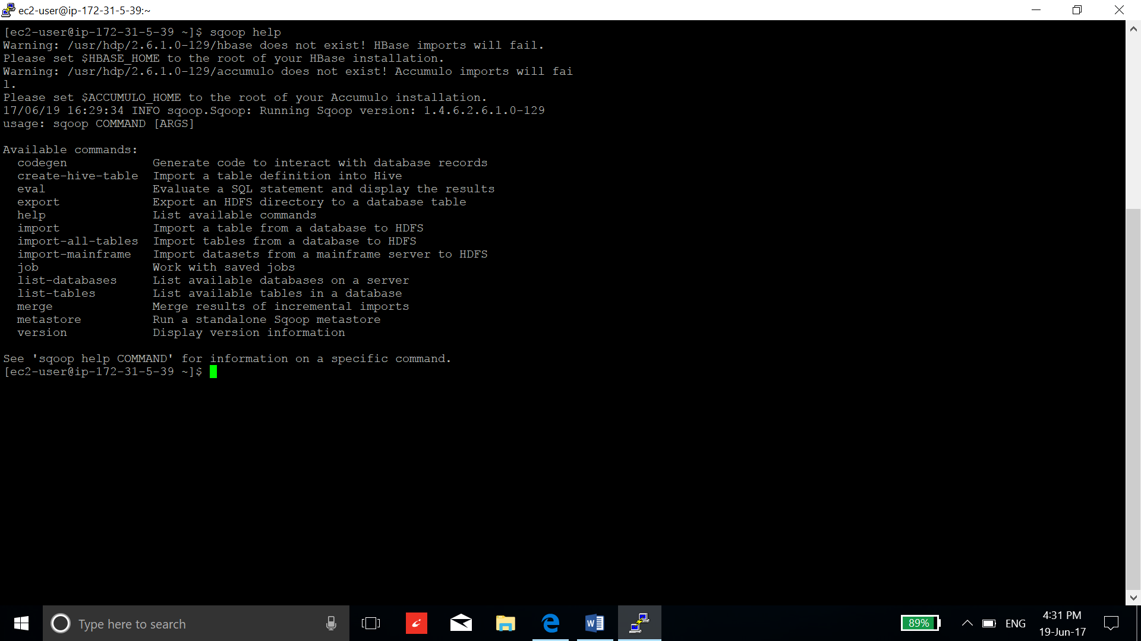

1. Install Postgresql or use the instance of Ambari-server because it has already installed the Postgresql during ambari setup. Now sign in to the postgresql and set the password.

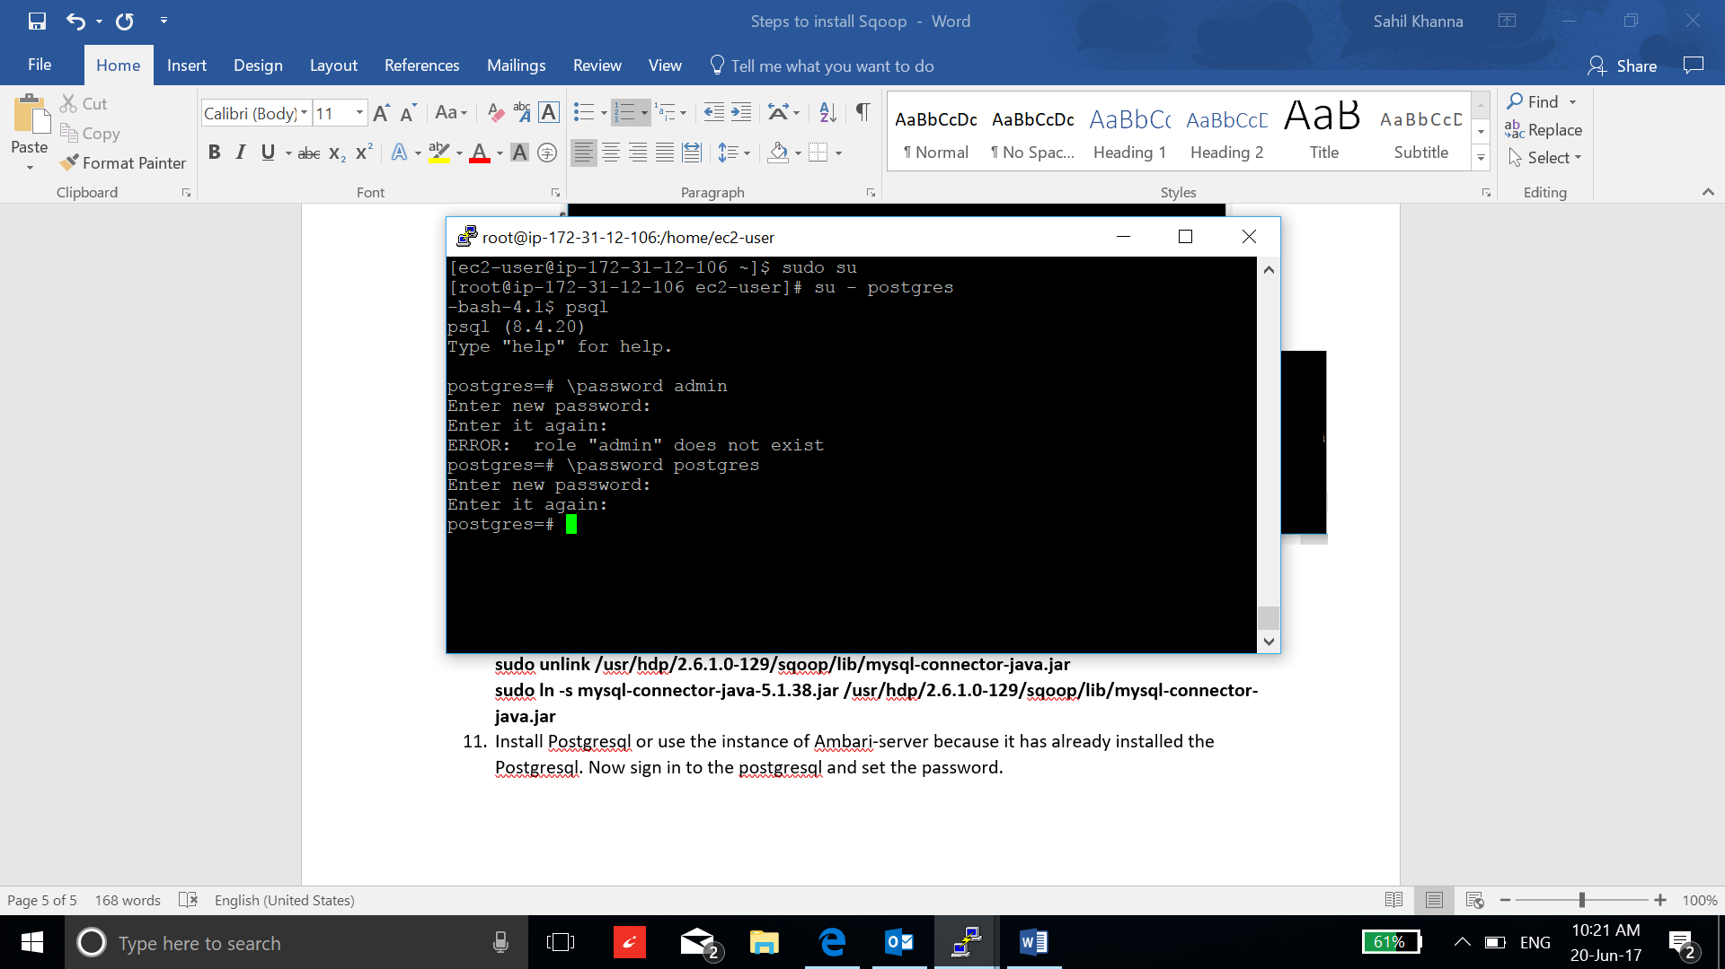

1. Now create database “demo”:

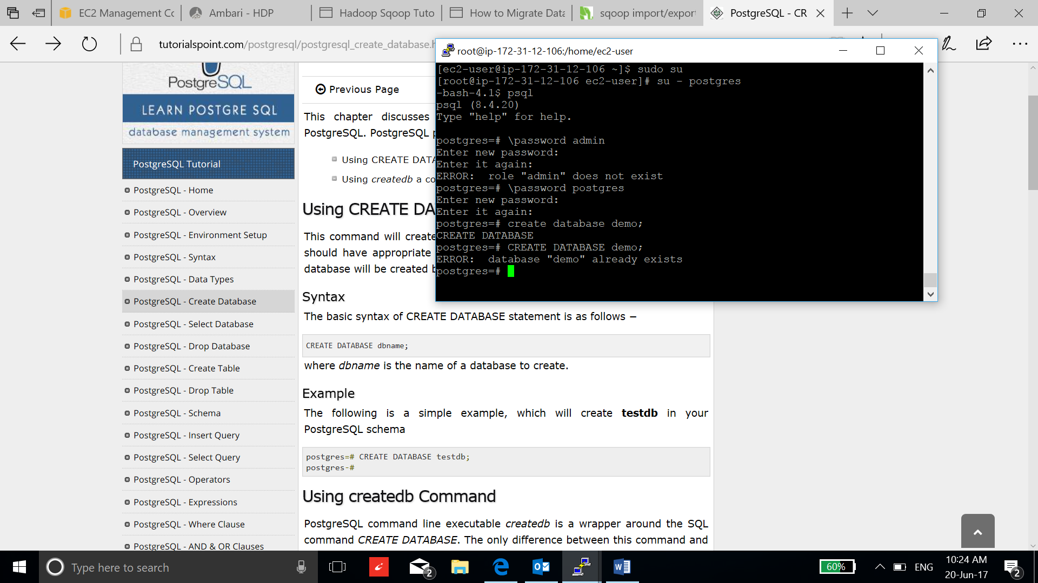

1. Connect to the database “demo”:

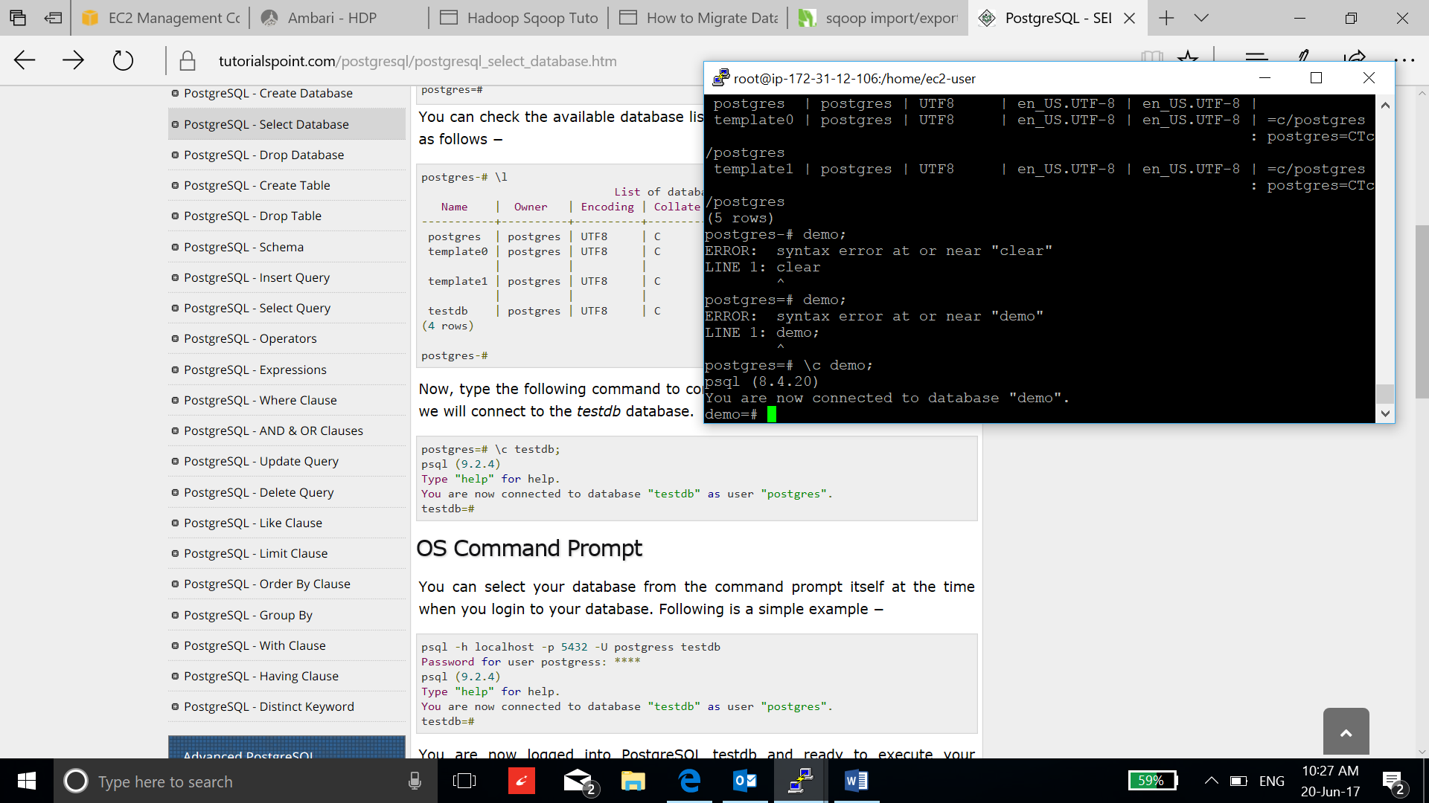

1. Now create a table to transfer HDFS:

**create table sales ( pkSales integer constraint salesKey primary key, saleDate date, saleAmount int, orderID int not null, itemID int not null);**

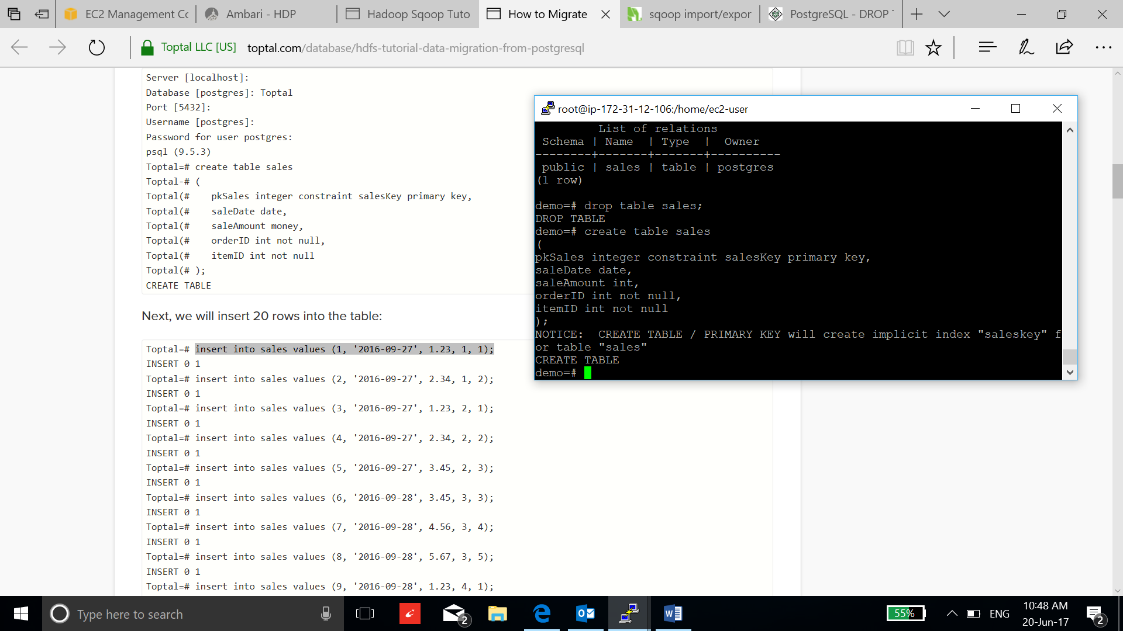

1. Insert the data into the table:

**insert into sales values (1, '2016-09-27', 1, 1, 1);**

**insert into sales values (2, '2016-09-27', 2, 1, 2);**

**insert into sales values (3, '2016-09-27', 3, 1, 3);**

**insert into sales values (4, '2016-09-27', 4, 1, 4);**

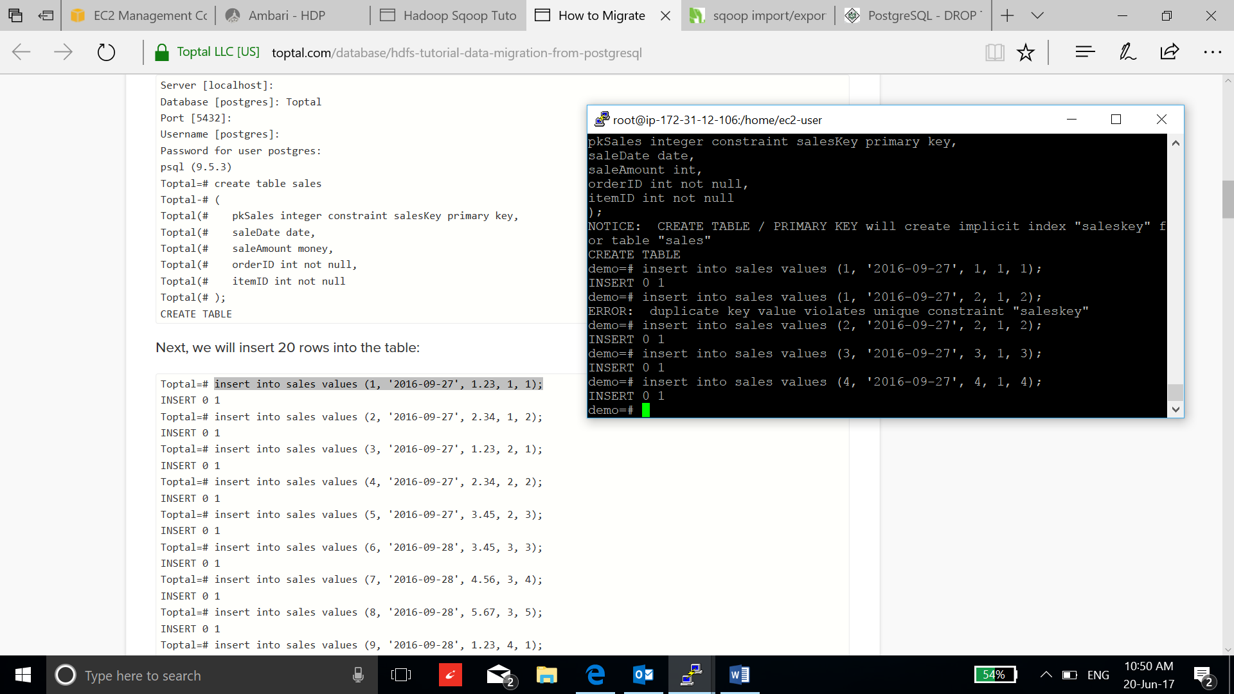

1. Now download the postgres driver:

**curl -L 'http://jdbc.postgresql.org/download/postgresql-9.2-1002.jdbc4.jar' -o postgresql-9.2-1002.jdbc4.jar**

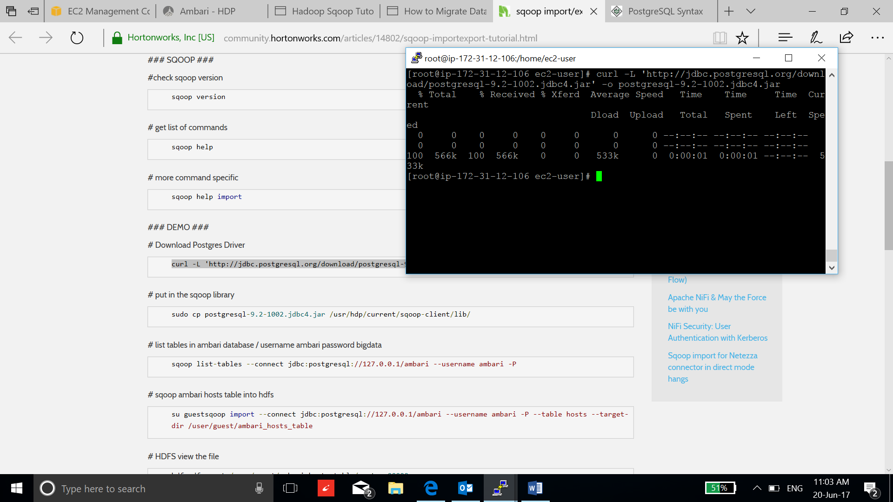

1. Copy the drivers in the sqoop library:

**sudo cp postgresql-9.2-1002.jdbc4.jar /usr/hdp/current/sqoop-client/lib/**

1. Open security connection to the postgresql database by editing pg_hba.conf file:

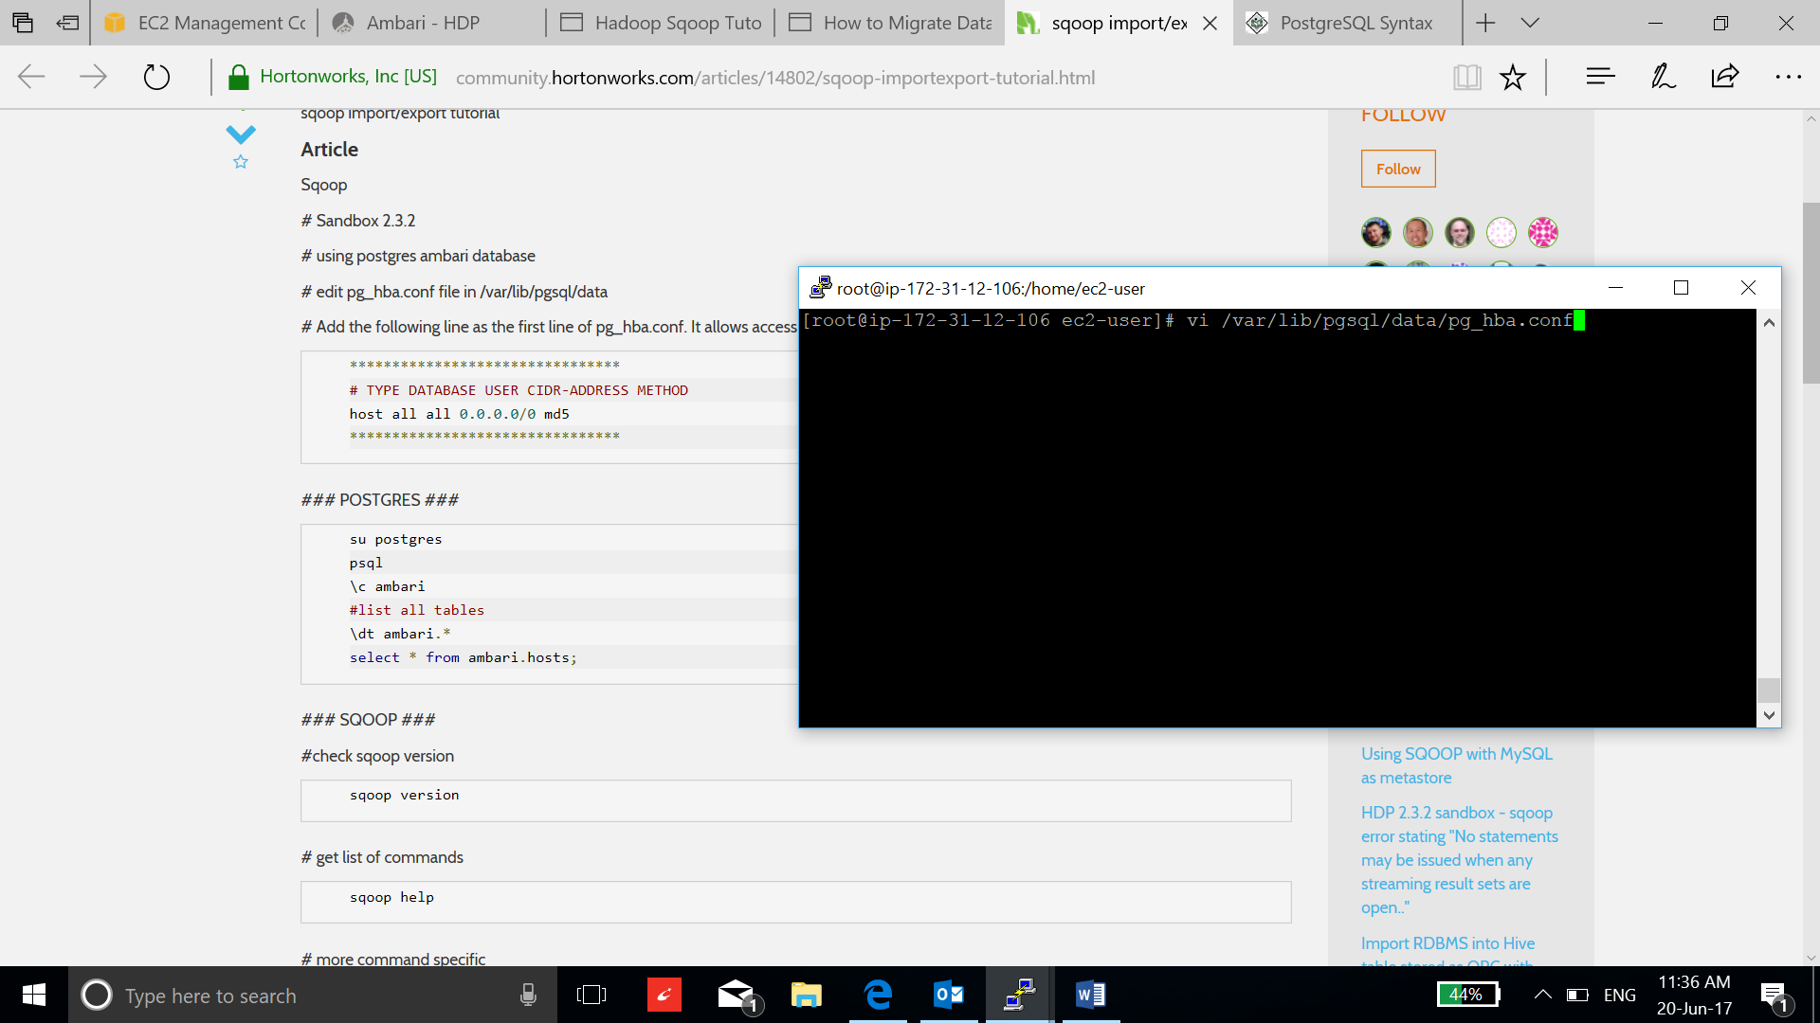

1. Add the host configuration line in the starting of the file and restart the postgresql:

**host all all 0.0.0.0/0 md5**

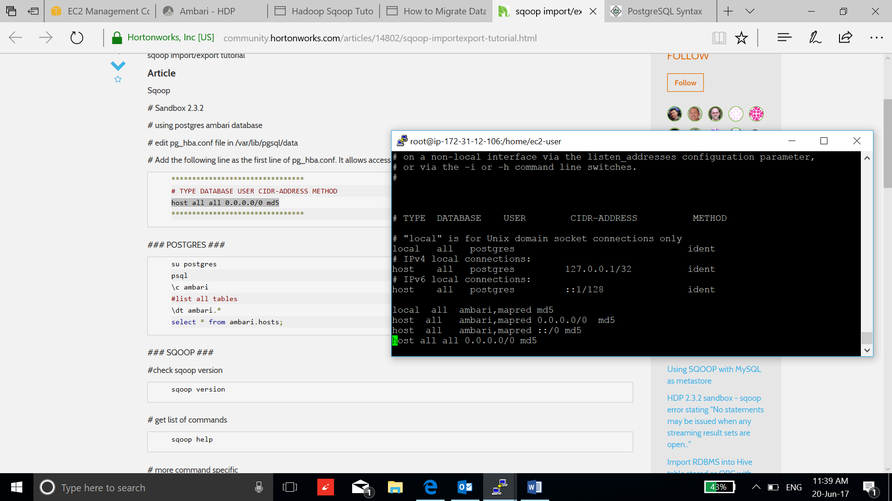

**/etc/init.d/postgresql restart**

1. Now list all tables in ambari database using username “ambary” password “bigdata”:

**sqoop list-tables --connect jdbc:postgresql://127.0.0.1/ambari --username ambari -P**

1. Now transfer the ambari hosts table in postgresql to HDFS:

**sqoop import --connect jdbc:postgresql://127.0.0.1/ambari --username ambari -password bigdata --table hosts --target-dir /user/guest/ambari_hosts_table_using_direct --direct**

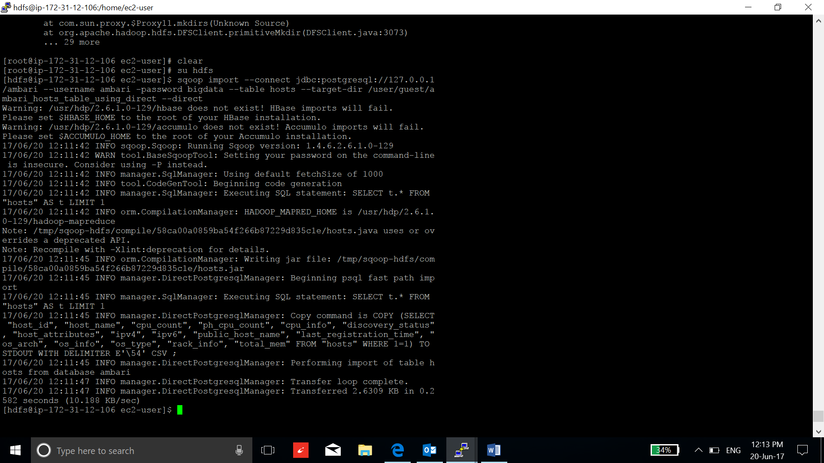

1. We can directly transfer the data into Hive using following command:

**sqoop import --connect jdbc:postgresql://127.0.0.1/ambari --username ambari -password bigdata --table hosts --hive-import --create-hive-table --direct**

1. Create the table using Hive and insert some data:

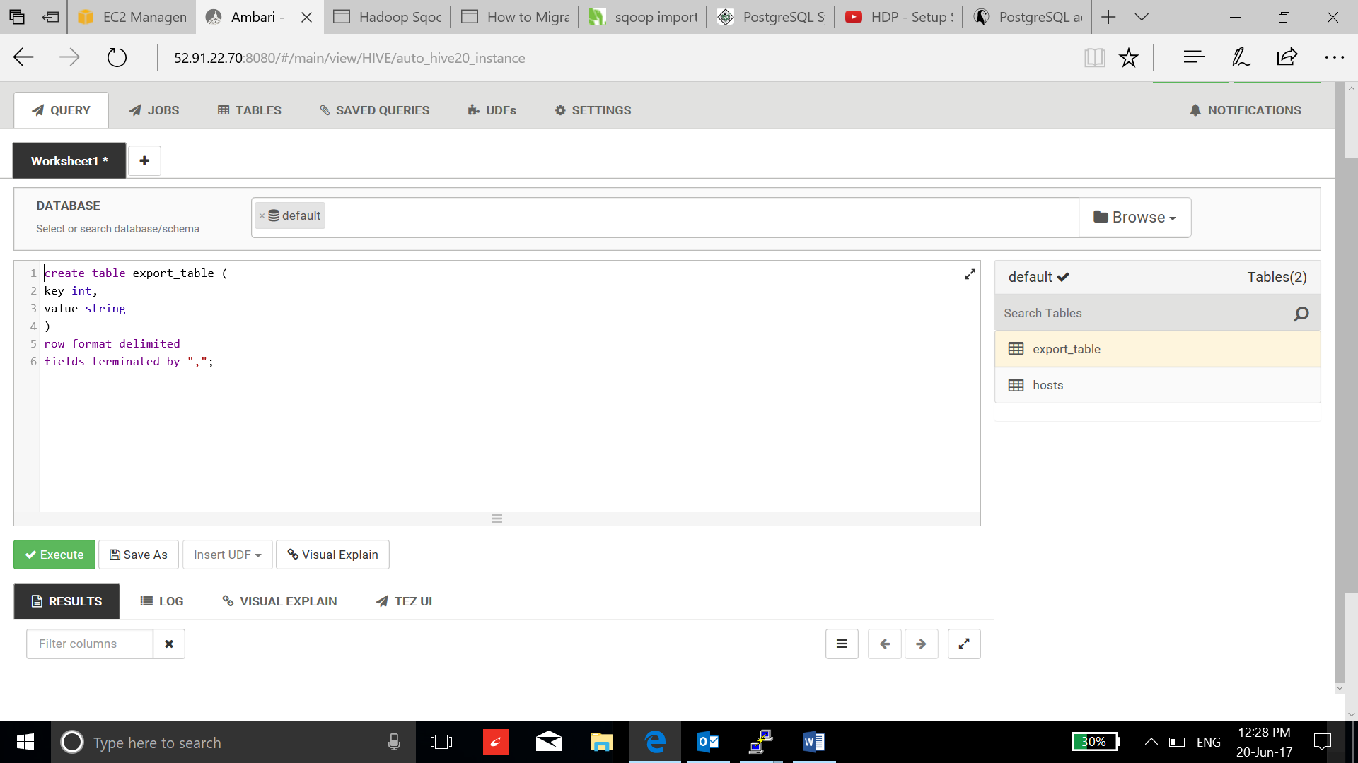

1. Display the table in HDFS:

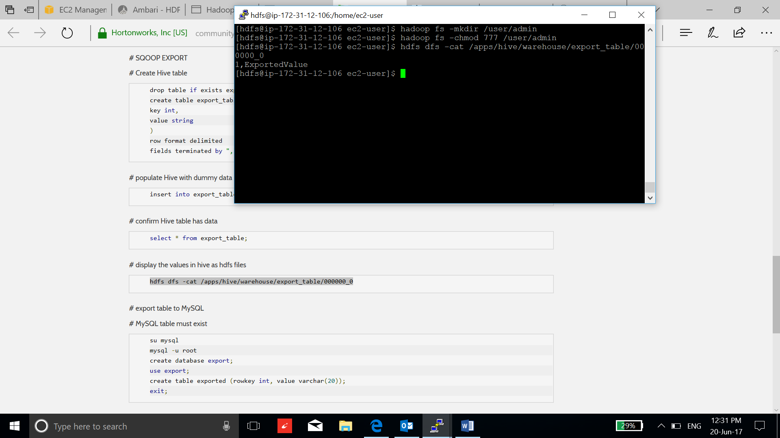

1. Transfer the table created by us from postgresql to hdfs:

**sqoop import --connect "jdbc:postgresql://ec2-52-91-22-70.compute-1.amazonaws.com/demo" --username postgres -password admin -table sales --target-dir /user/guests**

1. Verify the table:

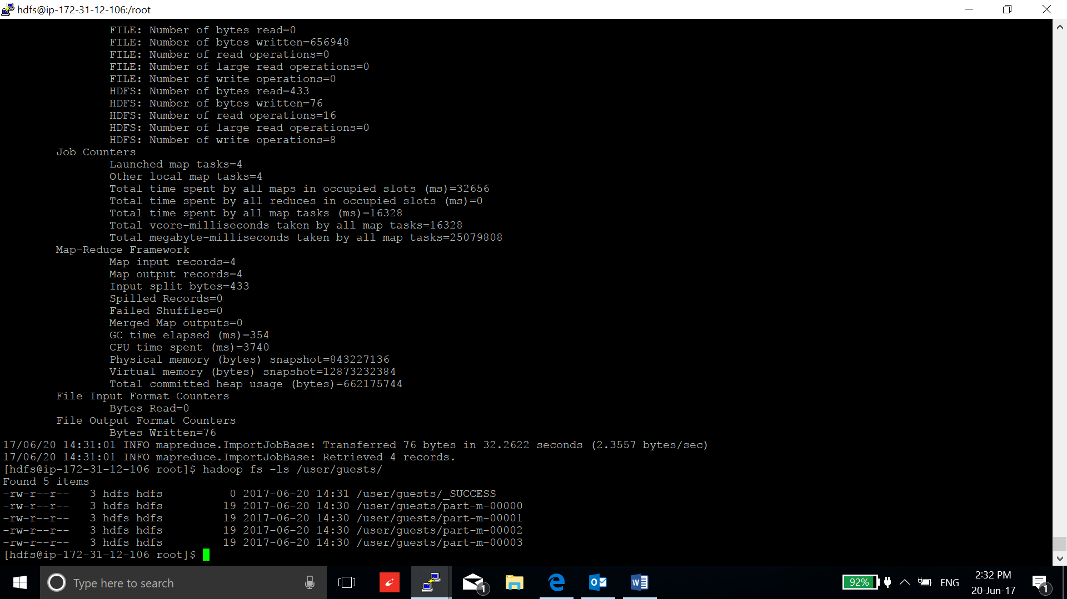

1. Create a table on postgresql to export the table from Hive to the database:

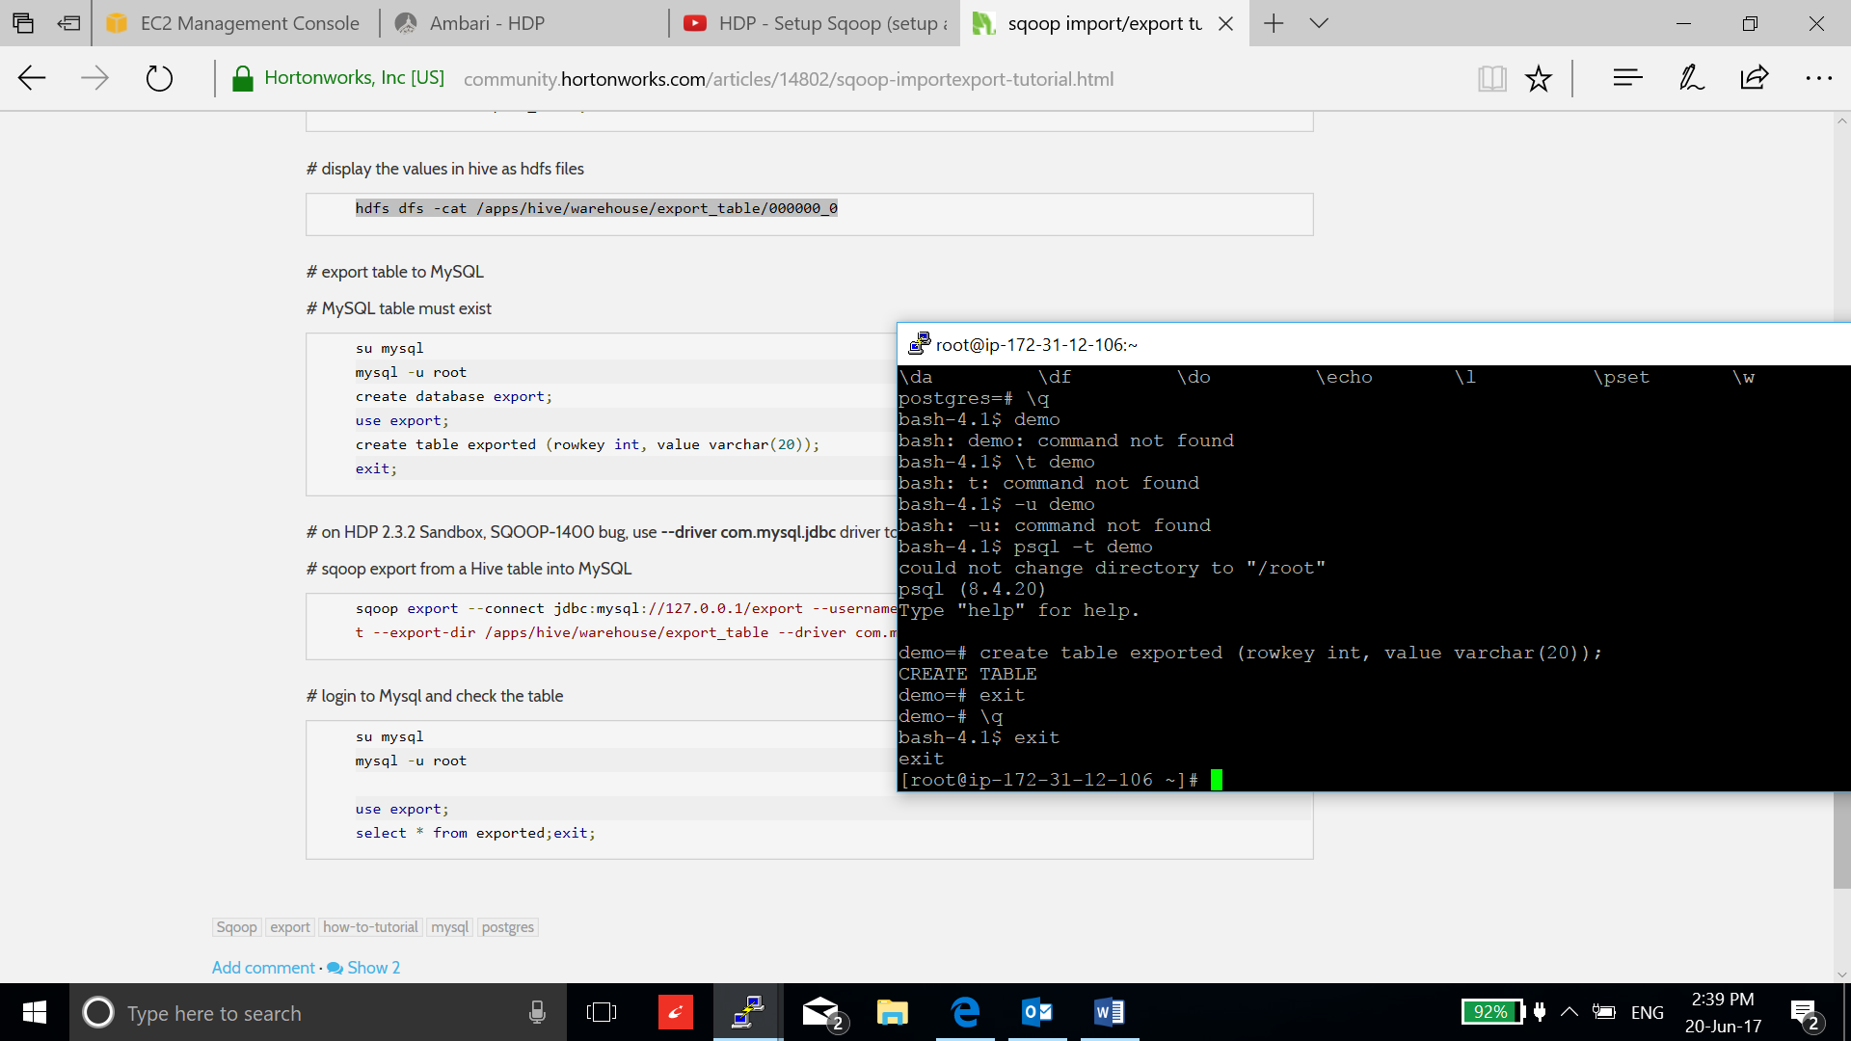

1. Transfer the table from Hive to postgresql:

**sqoop export --connect "jdbc:postgresql://ec2-52-91-22-70.compute-1.amazonaws.com/demo" --username postgres -password admin -table exported --export-dir /apps/hive/warehouse/export_table**

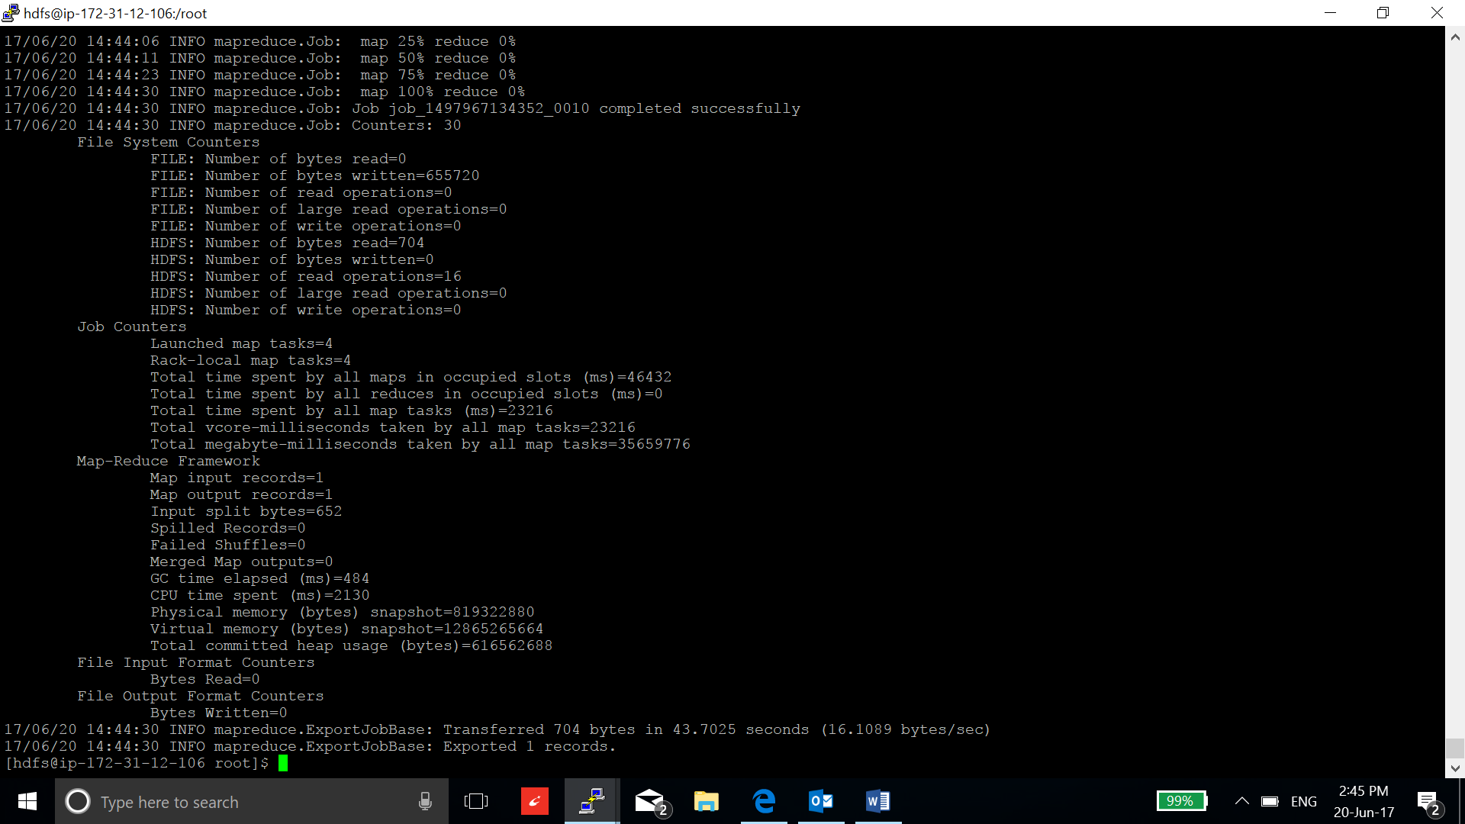

1. Verify the table:

